RESPONDING RESPECTFULLY: AUSTRALIA DAY FACEBOOK POST
Respect is having regard for the feelings, wishes and rights of others. Showing respect to someone means acting in a way that takes into consideration their feelings and wellbeing. This can include being courteous, showing empathy and acting with dignity. Respect is commonly an important value in different cultures and belief systems.
Respect works both ways. If you want others to treat you with respect, you have to give it as well. It’s okay to be yourself online and your opinion can differ from others – this is what makes us interesting and unique. However, expressing hate, racism, sexism and violence online is
not okay and can harm others. We all have a responsibility to stand up and speak out against offensive or harmful online behaviour.
There are lots of ways to respectfully share your opinion that can lead to interesting conversations. You might not always want to challenge ideas that are different to yours, but it’s important to stand up to things you see or view online that appear hurtful to others or may even be illegal.

How to communicate respectfully online:
- Put yourself in the other person’s shoes. Identify how the other person may have been feeling when they wrote the post/message. Ask what the post/message could mean to the other person given their experiences? Once you have identified the other person’s point of view, you can begin to empathise with their experience/feelings e.g. “It sounds like today is a really difficult day for you”.
- Present your opinion calmly. If you feel yourself getting angry or frustrated, take some
deep breaths or get some space from the situation. Once you are ready to respond, you respectfully reply by focusing on the ‘ideas’ presented rather than attacking the person (e.g. I disagree with your opinion, because .” Rather than: “You’re wrong because .”)
- Be curious! Ask questions to learn the reasons behind the other person’s opinion. If you
disagree with their opinion, rather than making an assumption or judgement, ask them how they formed that opinion or made that decision e.g. “Thanks for sharing. I’m interested in hearing more. Can you share where you got that information from?”.
- Find some common ground. Are there parts of their opinion that you agree with? Can you
use this as “common ground” in your reply? e.g. “I really agree with . I personally disagree with , because .”
- Speak up against disrespectful comments in a respectful way. Use assertive and confident
language to get your message across. You may also draw on your own values around respect to help you respond with confidence e.g. “It’s not okay to put someone down, everyone’s opinions can be voiced.”
- Think before you hit send. Take time to re-read and edit before you post anything. If you are
concerned that you might offend someone, get a friend or family member to read what you have written before you hit send.
- It’s OK not to respond to some comments and posts. Some people deliberately write
comments to try and get reactions. Not responding may be the best course of action in some situations.

FACEBOOK POST ACTIVITY
Instructions
- Read the Facebook post and comments below.

- 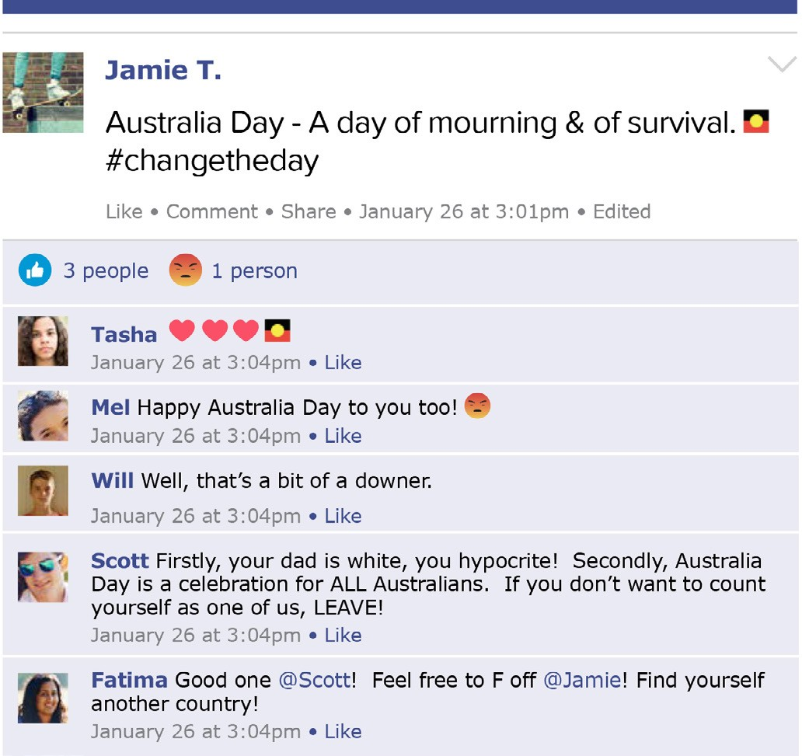Create three respectful replies to Jamie’s post:
- One reply that respectfully agrees with Jamie’s opinion.
- One reply that respectfully disagrees with
Jamie’s opinion.
- One reply as a respectful ‘upstander’ to the other comments on the post. An upstander respectfully speaks out against bullying, racism, sexism and discrimination regardless of whether they agree or disagree with the post or comments.

To help you get started, here are some example respectful sentence starters: “Thanks for sharing your experience! My experience is .”
“I can see that you feel .” “I feel . Because .” “There are lots of different opinions about this. My opinion is .”
“It was interesting to hear your perspective. My perspective is .”

1. Respectfully Agreeing Reply | 2. Respectfully Disagreeing Reply | 3. Upstander Reply

