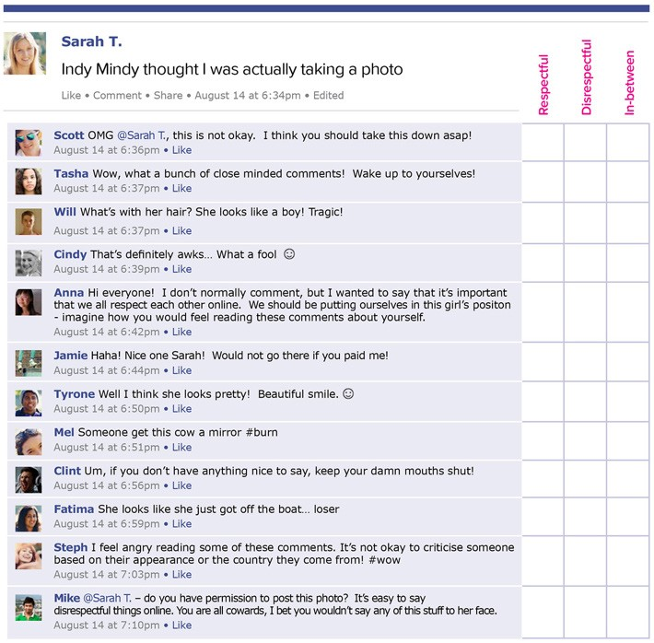
Student worksheet for Respect Lesson Plan 2

Instructions
- Read each of the comments on Sarah T’s post below.
- For each comment, tick ( ) the chosen box to rate the comment as either:
  - Respectful
  - Disrespectful
  - In-between

Defining Respectful, Disrespectful and In-Between comments:
- Respectful: Thoughtful response that considers others’ viewpoints as okay, gives any opinions in a calm and rational way, and doesn’t attack the other person for their opinion.
- Disrespectful: Response or opinion that expresses hate, racism, sexism or violence online. It may express that other people’s ideas, opinions, and values are not okay.
- In-between: Response may contain both respectful and disrespectful parts. For example, a comment that has elements of standing up for others but can be perceived as aggressive or attacking other people.

